**OFDM(****Orthogonal Frequency Division Multiplexer)**

In this document you will find my explanation of OFDM.

Let’s begin with a brief explanation of the term.

OFDM is a method of data transmission where a single information stream is split among several closely spaced narrowband subchannel frequencies instead of a single wideband channel frequency.

In a traditional single-channel modulation scheme, each data bit is sent serially or sequentially one after another. In OFDM, several bits can be sent in parallel, or at the same time, in separate sub stream channels. This enables each sub stream’s data rate to be lower than would be required by a single stream of similar bandwidth. This makes the system less susceptible to interference and enables more efficient data bandwidth.

It is a very popular technique and used quite frequently in wireless technology.

This method is typically used for a single user – we take a band of frequency, and divide it to multiple frequencies, using a multiplexer (MUX for short). Each subdivision of data is going to the same user and different data streams are being sent to each subdivision. In OFDM, we use coherent detection.

So, I’ve talked about the “dry” definition of OFDM. Now, we must ask ourselves – why is it a popular method? Why should we use this method over FDM (Frequency Division Multiplexing) or single channel? What are the advantages/disadvantages of OFDM?

To answer these questions, we will compare the methods.

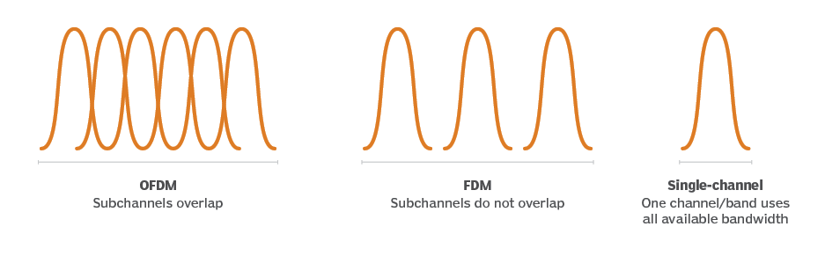As you can see from the image above, we have 3 techniques that we have previously mentioned – OFDM, FDM and single channel. Let’s briefly explain FDM and single channel.

**Single channel**

A system or a device that can only transmit or receive information along one path or route at a time.

Usage: simple designs such as radio, single-core cable or a mono speaker.

Advantages: simplicity, cost-effectiveness and reliability.

Disadvantages: limited capacity and reduced flexibility.

**FDM**

Used to transmit multiple signals simultaneously over a single channel by dividing the available bandwidth into smaller frequency bands. Each signal is assigned a unique frequency band, allowing them to be transmitted and received independently.

Usage: cable television, radio broadcasting and microwave communications systems.

Advantages: efficient use of bandwidth, simplicity and robustness.

Disadvantages: limited bandwidth, guard bands and inefficient use of spectrum.

As we can see from the explanations and the diagram, FDM and OFDM are similar.

Let’s focus on these 2 techniques as the single channel one is inferior in comparison.

For simplicity, here are the key differences between FDM and OFDM seen in the chart below.

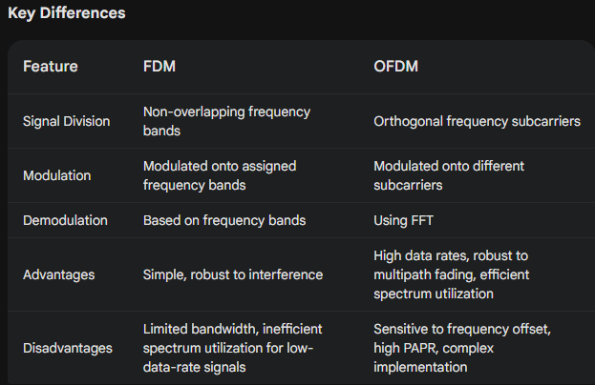

So now we understand why we use OFDM, its advantages and disadvantages.

Now I will dive deeper into this technique.

Let’s start with an example.

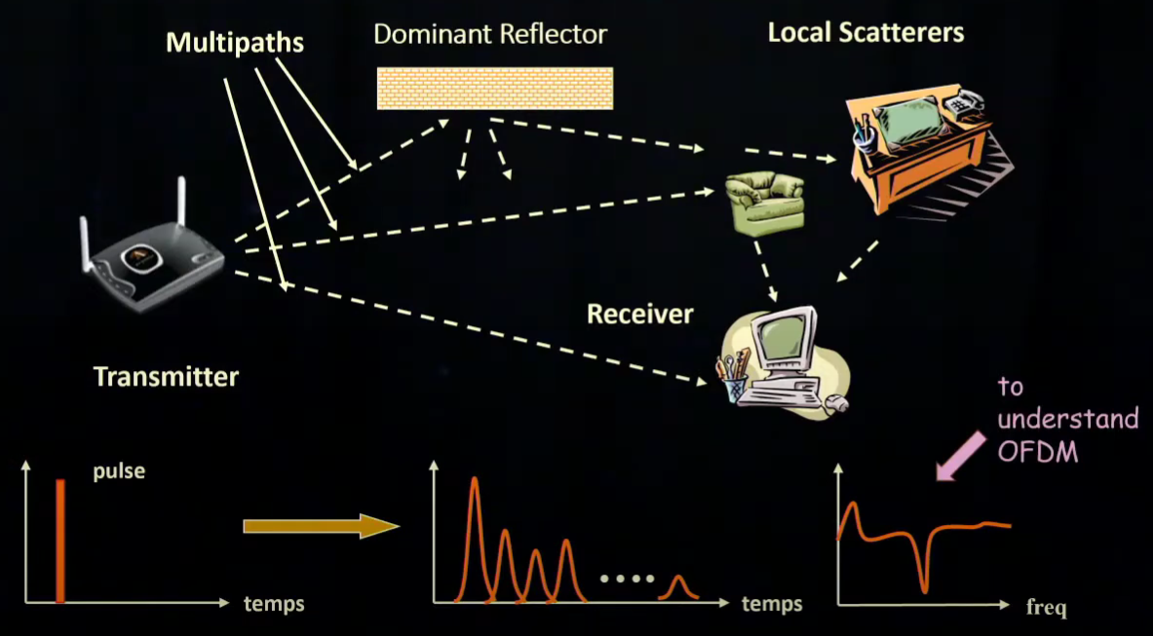

We have a transmitter and a receiver. We would like to send information to the receiver. In this scenario, we have a lot of paths that the transmitter can send that information to.

The receiver gets multiple returns from all the objects (shown in the middle graph).

To understand the solution, we will look at the frequency domain (the right graph) to avoid inter-symbol interference.

We’ve discussed that we have inter-symbol interference (ISI) when transmitting data.

To mitigate that interference, using OFDM, we will transmit data at a high frequency, but we will divide the data into several streams, transmitting the data in parallel using sub carriers.

If we transmit the data in series, we will get a lot of interferences. We could reduce the transmission rate in this method as well, but it will be less effective than doing it in parallel. We can also use equalization but in most cases, it is more complex and not worth the cost.

Let’s look at an illustration of how this method works:

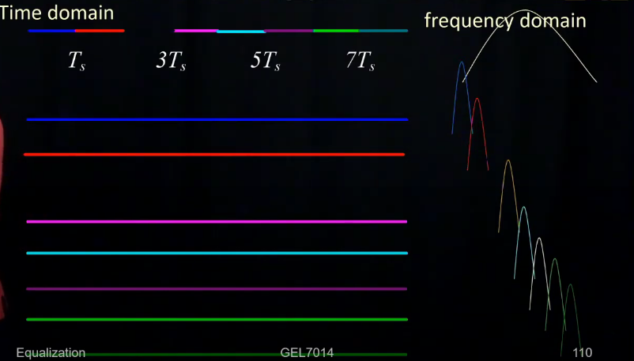

First, we have the data that we want to send – labeled , in 8 different symbol intervals. To make it clearer to understand, we will highlight each interval in different colors.

Because we are sending this data very fast, the frequency domain is very wide.

Now, we will send the 1st bit and transmit it for the whole duration (. Because we are going slower in the time domain, when looking at the frequency domain, we can see that the frequency domain content (the blue frequency) is narrow.

What happens is that we send all the bits for the whole duration in the time domain, therefore in the frequency domain, they will be narrow. We must not forget that the transmission is done in parallel data streams, giving eight subcarriers. Even if there are many reflections (cause of ISI), because of the slow transmission in the time domain, the reflections will die down because of the slow speed.

This is the key idea of OFDM.

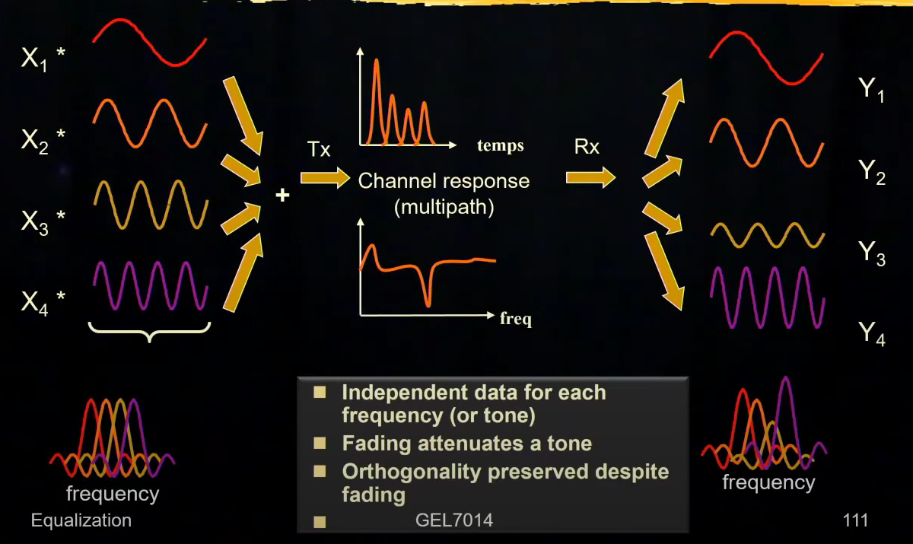So, how does OFDM modulation look like?

In this example we can see 4 different data streams (. All 4 of the data streams are sent in parallel on different frequencies but going out of 1 antenna. I want to take a closer look at the middle, specifically the graph with the frequency. We can clearly see there is a fade (drop) in the middle of the graph. These drops can occur for several reasons (that is the main trade-off when using OFDM). When a deep fade occurs, we might have to retransmit some data. In the end, we get the received signals combined. Looking at them independently we can clearly see they have been impacted and changed quite a bit.

Now, we need to talk about the modulations themselves.

For OFDM we can use: BPSK, QPSK, 16QAM and 64QAM. The bandwidth stays the same for these types of modulations, however, for 16QAM and 64QAM we could get a higher binary rate.

Deciding which modulation to use is determined by several factors such as distance and signal strength.

Up until this point I have talked about what is OFDM, the general use of it and how it works.

Now I will begin to talk about the implementation of this method.

Let’s look at the transmitter side of the process.

The process begins with FFT (Fast Fourier Transform) on the transmitter side. The FFT is implemented using a high-performance and inexpensive DSP (Digital Signal Processor).

To make the explanation as easy as possible, I will use the BPSK (Binary Phase-shift keying) modulation scheme.

In the example below we can see our data stream (52 bits comprised of 1 and -1).

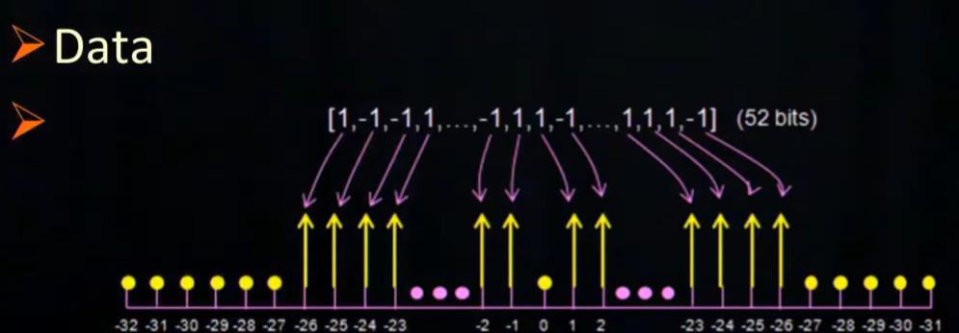

When looking at the data stream, we should be thinking of this data not as each bit going on the total frequency domain, but as each one of these bits being assigned to one subcarrier.

Now we need to look at this bit vector from a mathematical standpoint, to use FFT.

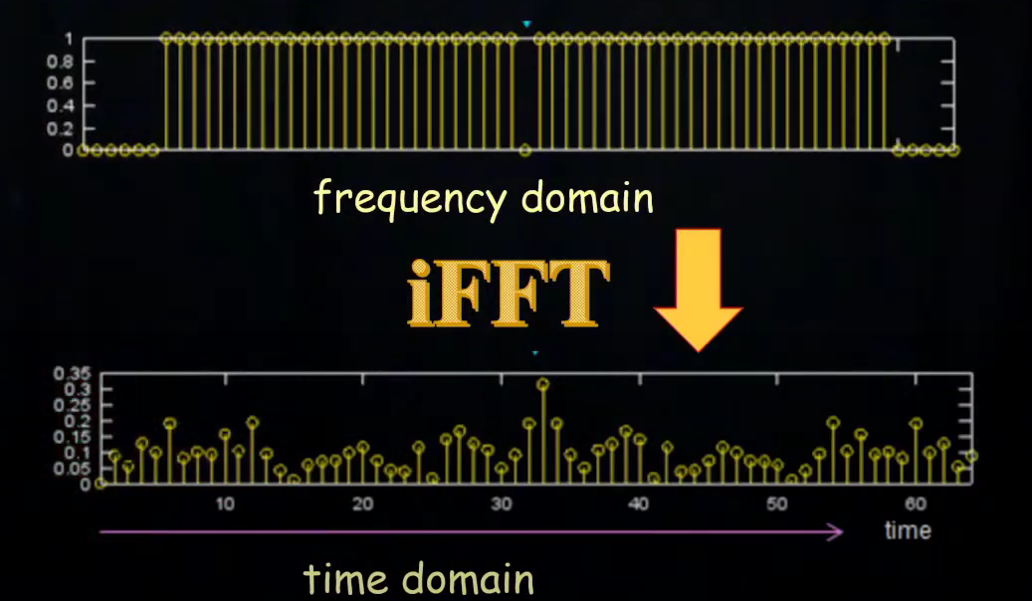We have a 64-element vector. Some of the bits are not used in the vector (in the example above, those are the dots – equal to 0). Looking at the 52 bits we can see 1 and -1, meaning the data that we want to transmit (we are going to plot the amplitude, they differentiate in the phase is 180 degrees). We interpret the vector to be in the frequency domain. Of course, using IFFT (Inverse Fast Fourier Transformation) on the vector – the vector will transform to the time domain. See the picture below.

After the transformation, this is the data that will be sent from the transmitter antenna.

For simplicity, this is a short diagram of the process so far:

Transmitter

DSP

Data

The data block is sent to our DSP which takes the frequency vector, converts it to time vector using IFFT, this vector is sent to the transmitter using DAC (digital to analog conversion) and at the end of the transmitter we are sending the data over a wireless link (Bluetooth, radio, Wi-Fi, etc.).

Below you will see the spectrum of the OFDM.

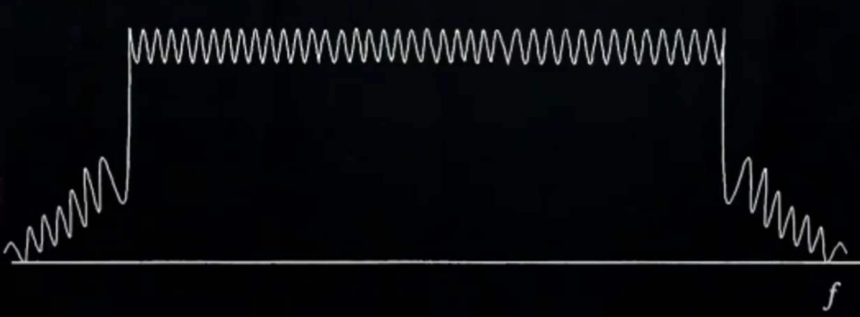

See how all the subcarriers are lined up one after the other for our transmission. This is a typical OFDM spectrum. If you are asking yourself – what are those steep ascents on the side?

Those ascents are caused by the signal itself – it is a narrow band signal. When looking at the wide scale it looks like a very steep ascent.

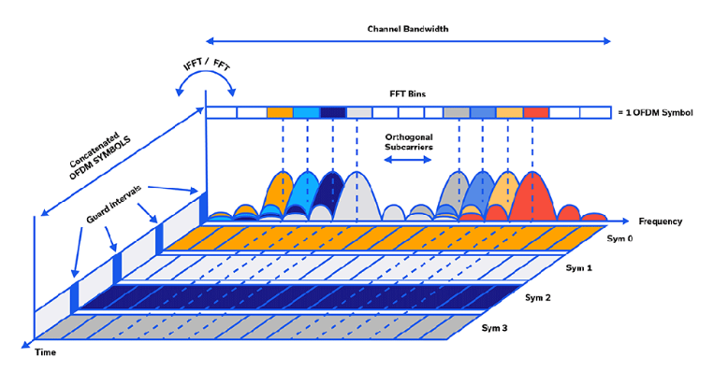To really sum up this part of the process I want to look at this diagram:

Before panicking, I will go step-by-step to explain this diagram.

We have 2 scales – frequency and time.

Firstly, if we look at the time axis, you’ll see some guard times which are put in place between the symbols. In one OFDM symbol we have the 52 bits which we have previously talked about. In the time domain, all the bits are mixed-up, however, in the frequency domain they are all isolated and easily represented. The guard bands are used to make a concession to the multi-path delay spread, meaning long enough for the delay spread to balance out. Of course, the delay spread is not tolerated for 1 bit, but for 1 symbol (the whole 52 bits being sent), making the overhead being substantially lower. The guards make sure that the different frequencies to be all finished during the transmission.

Secondly, in the frequency domain the symbols stay the same (unlike in the time domain). We have FFT Bins which is made up of 52 bits (for example, the 1st bit = 1 is the orange frequency), which represents what is going on in the frequency sub carrier.

In summary, OFDM divides the available channel bandwidth into multiple orthogonal subcarriers, allowing for efficient transmission of data in a frequency-selective environment. The use of FFT/IFFT and guard intervals helps to improve the reliability and performance of OFDM systems.

Now, let’s look at a typical OFDM modem diagram and explain it.

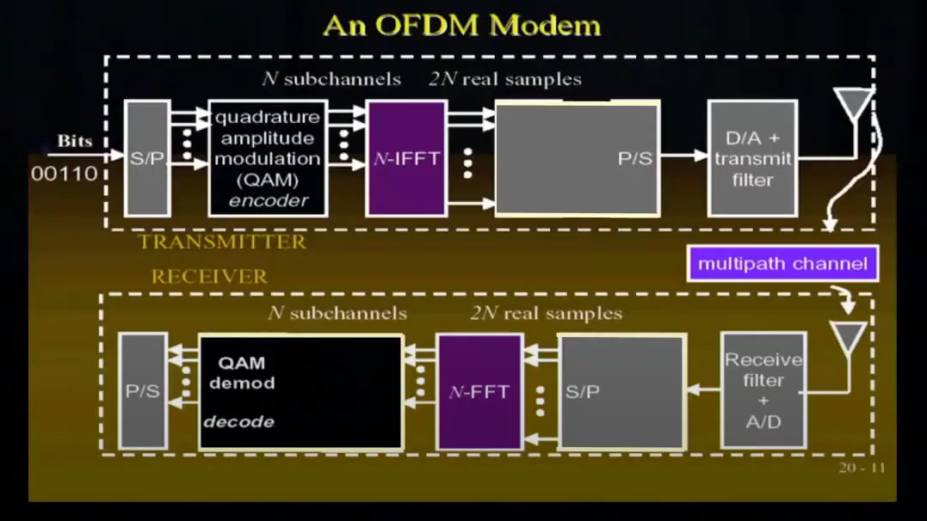

At the start, we see some bits entering S/P (series to parallel conversion). Next, we modulate those bits using an encoder (in this diagram, QAM is used). Those bits enter the DSP which handles the IFFT for the N number of subchannels, then that data is converted from parallel to series and that time series is sent for transmission.

As you can see from the diagram above, a very similar process happens when receiving the data. We have an antenna which receives the data, converts it from analog to digital, goes through series to parallel converter, converts the data using FFT, goes through demodulation and once again goes through parallel to series converter.

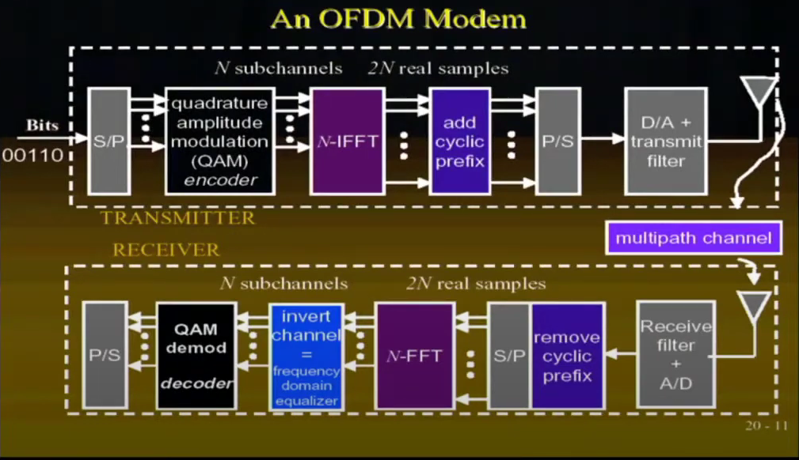This is the basic OFDM modem diagram. I have omitted some steps from the process to simplify the explanation. Once you have understood the diagram above, let’s look at the expanded diagram below:

As you can see, I have added a few components to the diagram.

The cyclic prefix corresponds to the guard time which I have talked about earlier. Adding a cyclic prefix guarantees the full period of the carriers. A portion of the time-domain signal is appended to the beginning of each symbol. This prefix is a replica of the end of the symbol. This creates repetitions of oscillations in the carrier so that the orthogonality is maintained despite the delay spread in the channel, thus eliminating the impact of the reflections in the channel. Note that the cyclic prefix has no data on it, it’s just meant to preserve orthogonality.

In the receiver we later remove the cyclic prefix.

Now we will look at the domain equalizer. At the beginning of this document, I talked about how to deal with interference, specifically not using an equalizer. The whole point was to avoid using it but this equalizer (in the diagram above) is very simple, called a one tap equalizer. The one tap equalizer is just doing one correction, the premise of it is not to remove ISI, but to do good coherent reception.

I will go to further detail and explain the one-tap equalizer.

The one-tap equalizer is used to achieve coherent detection. In our example, we have a lot of subcarriers in our transmission, but we have only one oscillator for all of them making all the subcarriers have the same center frequency (see the image of the OFDM spectrum). Because we have one oscillator, the complexity of the equalizer is low.

One-tap equalizers provide a simple and effective solution for channel equalization by applying a separate tap coefficient to each subcarrier. This can effectively mitigate the effects of frequency selective fading (phenomenon where different parts of the frequency band experience varying levels of signal fading due to the characteristics of the channel) and improve the overall system performance.

Also, the phase of each subcarrier can vary. For that reason, we invert the channel which handles the phase change.

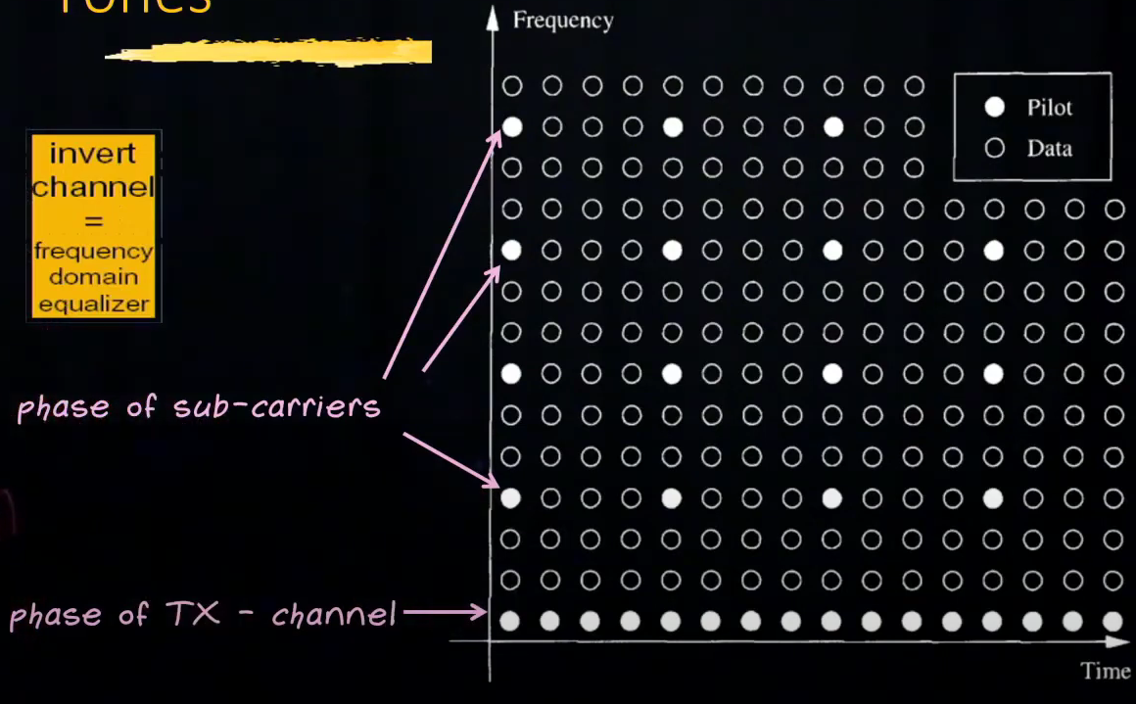I want to take a closer look at inverting the channel. For that, I will show you a diagram and explain how the invert channel works.

From the image above we can see a time domain axis and a frequency axis. The diagram is filled with circles colored in white or black. The white dots are pilot (a pure carrier), and the black dots are data. Each row represents a different subcarrier, and the time is one OFDM symbol. Even though there is only one physical oscillator (mentioned previously), because of the channel effects, the phase will probably vary a little bit from each subcarrier to subcarrier. For that reason, we have the first row of pilots which estimates the phase of our oscillator at the transmitter. We have one channel for frequency that we reserve just so we can keep an eye on that oscillator, to track its phase. Because of time drift, we are reserving the whole first row with pilots. Every now and then we are going to look at a subcarrier and check if the phase has changed significantly and we observe what it is using the pilot (in the diagram – phase of sub-carriers). For example, if a 5º rotation was introduced, we simply multiply by -5 rotation to get rid of the “incorrect” phase.

This was my explanation of OFDM, I hope you, the reader, learned something new or maybe it helped you understand this technique a bit better.

If you are interested in a simulation of the OFDM process written in Python, check out my example: [Coding-Projects/OFDM at main · TomSimkin/Coding-Projects (github.com)](https://github.com/TomSimkin/Coding-Projects/tree/main/OFDM)

Thank you for reading 😊

*This document was written using the following materials:

[GEL7114 - Module 4.12 - OFDM introduction (youtube.com)](https://www.youtube.com/watch?v=i3LBGw8Yle4)  
[GEL7014 - Module 4.13 - OFDM implementation (youtube.com)](https://www.youtube.com/watch?v=oOOS9xDXLaU&t=959s)  
[Gemini (google.com)](https://gemini.google.com/app)  
[The Basics of Orthogonal Frequency-Division Multiplexing (OFDM) - Mini-Circuits Blog (minicircuits.com)](https://blog.minicircuits.com/the-basics-of-orthogonal-frequency-division-multiplexing-ofdm/)  
[What is orthogonal frequency-division multiplexing (OFDM)? (techtarget.com)](https://www.techtarget.com/searchnetworking/definition/orthogonal-frequency-division-multiplexing#:~:text=Orthogonal%20frequency%2Ddivision%20multiplexing%20is,a%20single%20Wideband%20channel%20frequency.)